AAA’s Electrified Member Benefits
mEMBER BENEFIT OVERVIEW
AAA ELECTRIC VEHICLE CAPABILITIES
December 2022

All the Electric Vehicle Perks That Come with your AAA membership!

Electric vehicles are not new to AAA. Over the past decade, we have committed to learning, developing, and servicing electric vehicles as their popularity has grown. We offer a variety of benefits specifically for electric vehicle owners, including discounts at charging stations, support from our Roadside Assistance teams, plus, AAA’s travel planning tools that make road trips easier to plan and more fun! Whether you are already driving an electric vehicle or considering making the switch, AAA is here to help.

Mobile Charging Wherever You Need It
AAA understands that range anxiety might be the thing standing between you and venturing into the world with an electric vehicle. So, we want to eliminate that anxiety by introducing roadside assistance in select markets for our members who already drive electric or are considering it. If you run out of charge, we will come to you and give you enough boost to get you to the nearest charging station or home. The best part – for AAA members, this service is provided at no additional charge.

AAA members can now request roadside electric vehicle charging services in these select cities:

Orlando, FL
Nashville, TN
Charlotte, NC
Denver, CO
Grand Rapids, MI
Avon, MA
Providence, RI
Peabody, MA
West Springfield, MA
Bend, OR
Portland, OR
Indianapolis, IN
San Francisco, CA
Philadelphia, PA

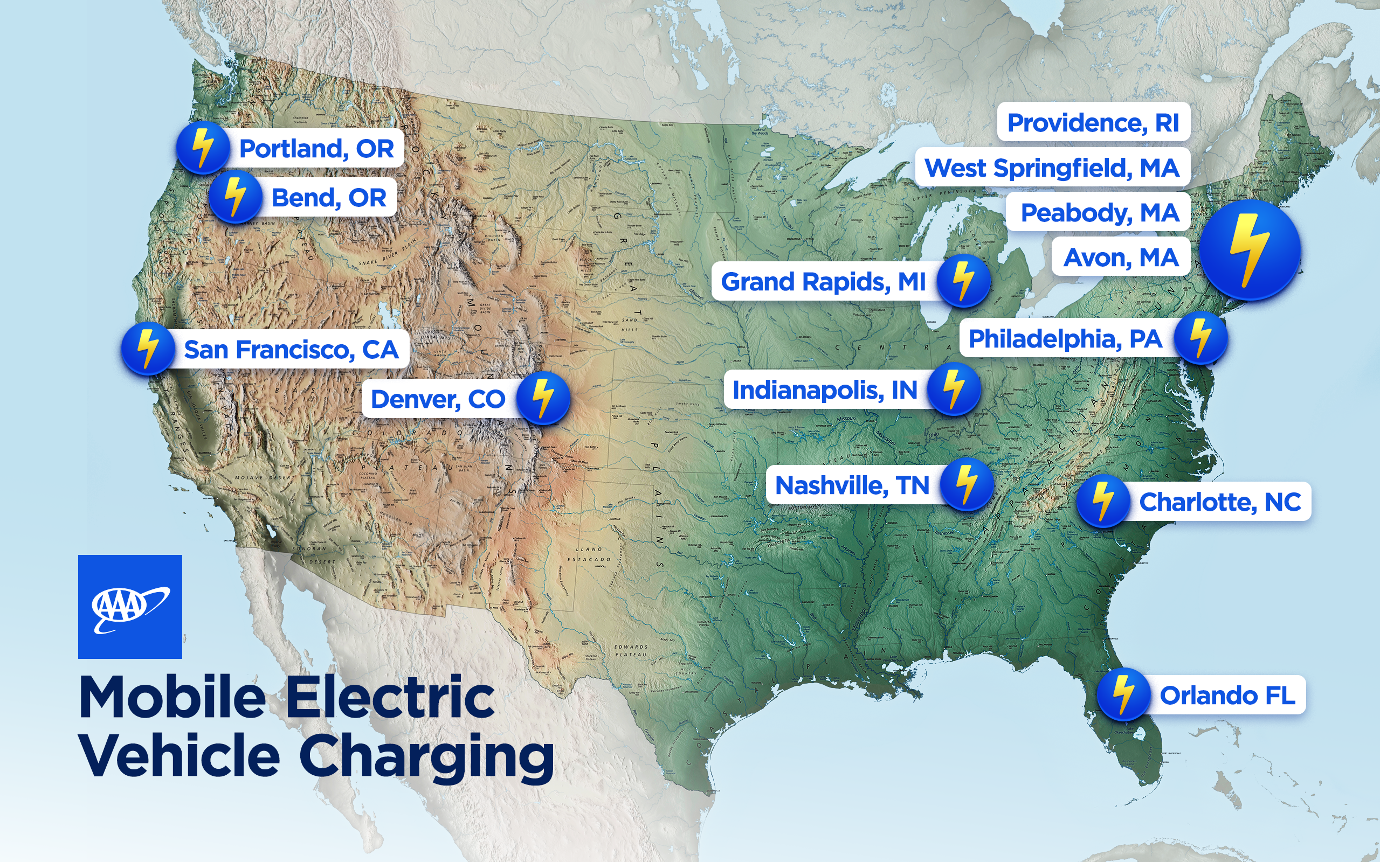

Road Trip Planning with AAA
The open road can be a fun and exciting place! We understand about range while driving your electric vehicle can play a huge role in how comfortable you feel adventuring out onto the open road. AAA has various digital travel planning tools that electric vehicle users can utilize to locate charging stations, save favorite or frequent trips for future travel, and discover extensive destination info with points of interest.

TripTik: The AAA TripTik Travel Planner can help you plan your road trips and find electric vehicle charging stations along the way. Currently displayed under fuel, sort charging stations by levels, distance from route, address information, and more. Plus, it's easy to identify electric charging station details with unique iconography. With the AAA TripTik travel planner, planning your next road trip just got a whole lot easier. Make sure to hit the road with confidence and let us help with charging station info!
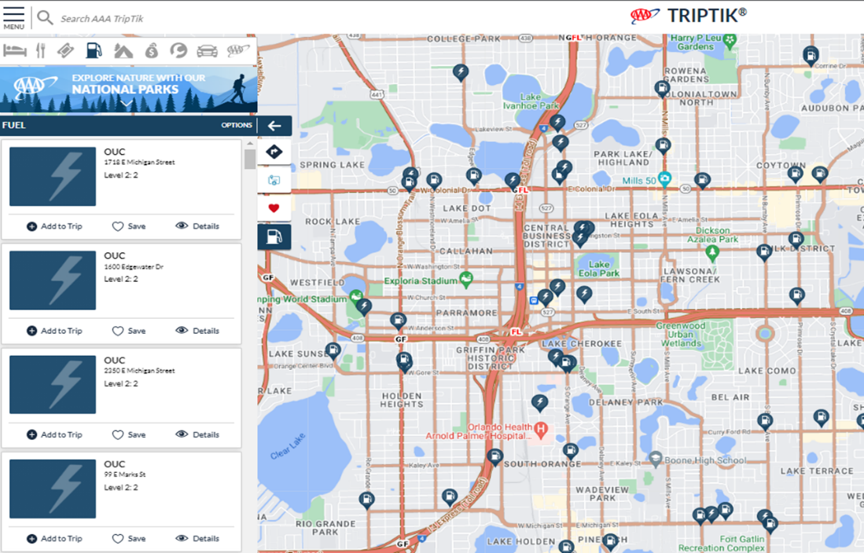

AAA Tour Books: Since 1926, you’ve trusted the travel information in our free TourBook guide to help plan your most memorable vacations. Now you can access AAA's expert travel advice in an eco-friendly format, available on any device including your smartphone, tablet or desktop. With just a few taps or clicks, you've got access to charging station details and their individual listings like hotels. Soon, you’ll be able to show public charging station locations on the map. Stay tuned!
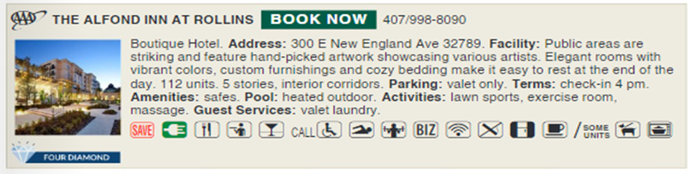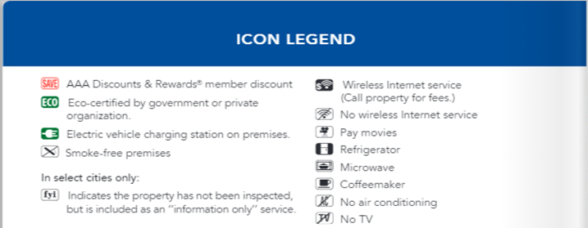

Trip Canvas: A brand new digital planning tool, Trip Canvas helps you dream, plan, and share future road trips by selecting where you want to go, when you want to be there and what your interests are to start exploring! Coming soon, electric charging stations with curated roundtrips!

Electric Vehicle Charging Cash Back Rewards
As you can see, we have you covered with roadside assistance and planning your dream road trip, but how about earning cash back just for charging your electric vehicle? AAA is proud to offer an extraordinary credit card designed to reward consumers for everyday living — whether at home or away. The AAA Travel Advantage card offers 5% cash back for every $1 spent at electric vehicle charging stations. View full disclosures here, visit your local AAA, or aaa.com/creditcard to learn more.

AAA Car Guide
AAA has also invested resources in developing consumer education pieces like the AAA Car Guide, to help car buyers understand the latest automotive technology.

Our Promise to Our Members
AAA members tend to join for the long haul, which means their relationship with us spans many years. And just like any good relationship, we are here for our members for all the big (and little) moments in their lives. Whether it is helping you out on the road no matter what vehicle you’re driving, offering exclusive discounts traveling or at home, or providing research insights to help keep you safe, AAA always has you covered. We are proud to say we have been doing that for our members for over 120 years and promise to evolve with you while the world does too!

